## CSIS1175 Assignment 3 Fall 2015

**YOU CAN DO THIS ASSIGNMENT WITH 1 PARTNER (NOT 20)**

**Due Date: Nov. 12th/2015**

**Create the following application**

This assignment is based in part on **Chapter 6 Ouestion 5 (Joe’s Automotive)**, but will have some changes in functionality as detailed below.

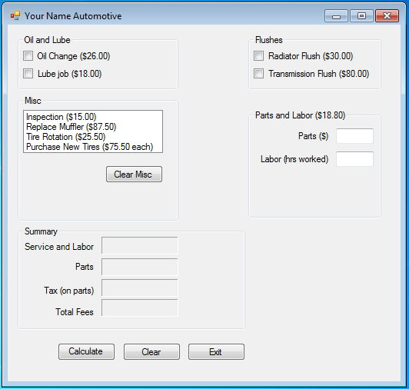

**Note:**

1. Use your **own judgement** on the sizes of the various GUI components
2. The font for the labels and text boxes should all be default.
3. Please replace “Your Name” in  with your own name.
4. Please **use the prices as indicated above** rather then from the text (although they are almost the same)
5. The **sales tax** is **6%.**

**Functionality**

The main functionality is the same as indicated in the text book. However, the following are **some of the changes for this assignment**.

1. if the user selects  from “**Misc**”, as soon as the user clicks on it, a **new list box** shows up, i.e.:

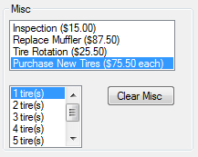

This new **tire listbox** allows the user to choose how many new tires to purchase, **with 1 tire(s) selected as default (this should be done by code)**. The tire listbox will have **7** items, i.e. 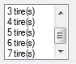.

**Note, if the user selected any of the first three options, the tire listbox does NOT appear**.

1. When the user clicks the  button, it should remove the **tire listbox** ( **make it invisible rather than actually removing it)**). Itshould also **clear** what was selected in the Misc listbox. So, below shows what it looks like after clicking . Note you **clear the selection and NOT** the items in the listbox.

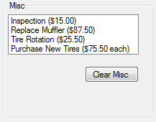

Note, if the user had selected one of the first three options, by clicking , it should also clear that selection, leaving the Misc listbox as shown above.

1. For , the **Parts** will indicate **how much was spent** on additional material. The labor will indicate how many hours was spent on the car. It will be at **$18.80/hr**. if the user clicks the  and nothing was entered (OR is non numeric) in either text box, then the following appears below.

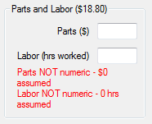

The following are some other examples:

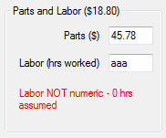 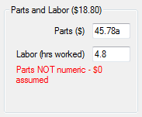 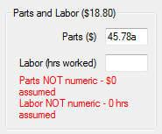

1. He main  button at the bottom of the form will clear the values of all the text boxes and checkboxes. In addition it should **also clear the error messages** from Parts and Labor as well as removing the tire listbox and clearing the selection in the Misc listbox. The following shows the form after clicking the  button.

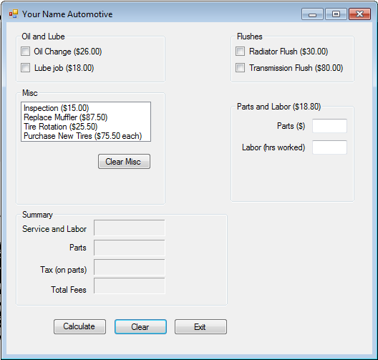

**Examples:**

The following shows examples of the calculations to perform.

a)

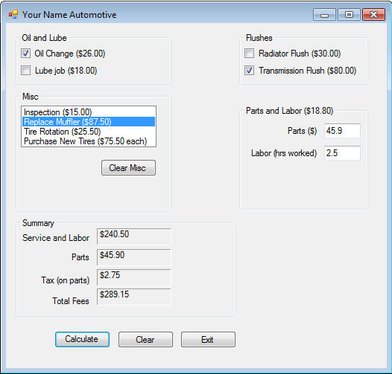

Note, service and labor is the **sum of labor cost (at 18.8/hr) and Misc, Oil and Lube and Flushes**.

**Also make sure to display all figures in the Summary section in currency format**

b)

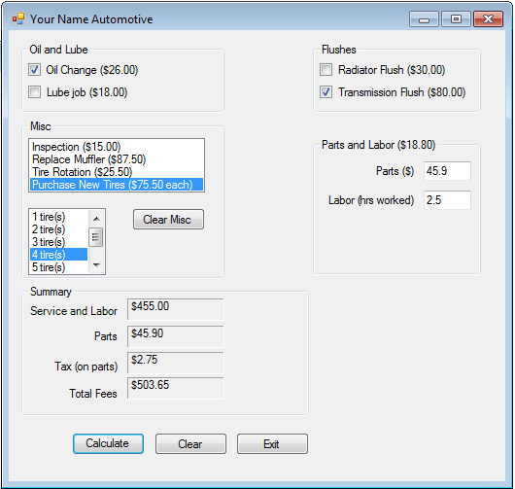

Note, the above shows the purchase of **4 new tires at $75.50** each as the Misc cost.

c) Below shows that hours worked for labor was entered incorrectly, so 0 hrs was assumed in the calculation.

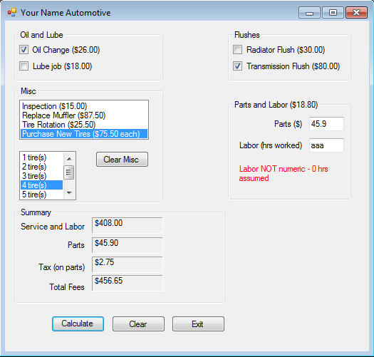

**Methods and additional methods required**

The methods will be those as indicated in your text book on **Chapter 6 Ouestion 5 (Joe’s Automotive).** In **addition** please also create the following:

* **ClearMisc(..)**

This method should clear the selection made in the Misc listbox as well as removing the tires listbox.

* **AddTires(..)**

This method should add the items into the tires listbox. However it should be written in such a way that the programmer can add as many items as he or she wants.

(Hint: you will need as parameters an **integer to indicate how many items** and a **listbox object to indicate which listbox to add the items to**)

* **CheckForNumeric(..)**

This method should allow you to check if the text inside **a particular textbox** is **numeric** or not. It should return back a boolean value to indicate whether it is numeric or not.

(Hint: you will need a **textbox** object as a parameter).

**What to hand in:**

1. Front cover page with your name (your partner’s name), course, assignment number, instructor’s name, section and due date. (If you did this assignment with a partner, then hand in **ONE** piece of work with **BOTH** your names on it).
2. Hardcopy of the program listing of **Form1 cs**
3. Either zip up all files, call it **CSIS1175F2015yourNameAS3.zip and upload via File submission through myDouglas**

**OR**

Hand in Disk containing all necessary **source** files.

**(If you did this with a partner, then please hand in one piece of work with both your names on the cover page.)**

**PLEASE ENSURE THAT THIS IS YOUR OWN WORK OTHERWISE MARKS WILL BE LOST AND WORSE !!!!!!**